React Application:
Installed node and npm
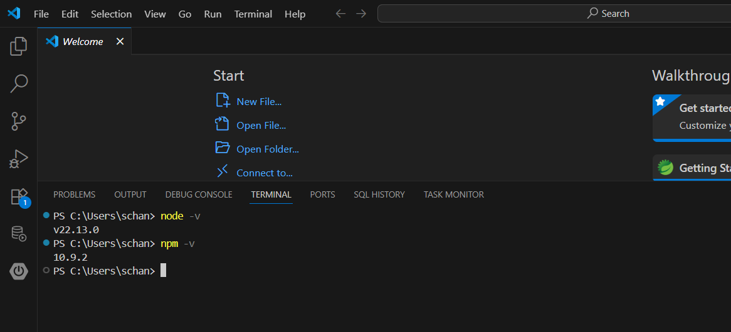
Create react app globally
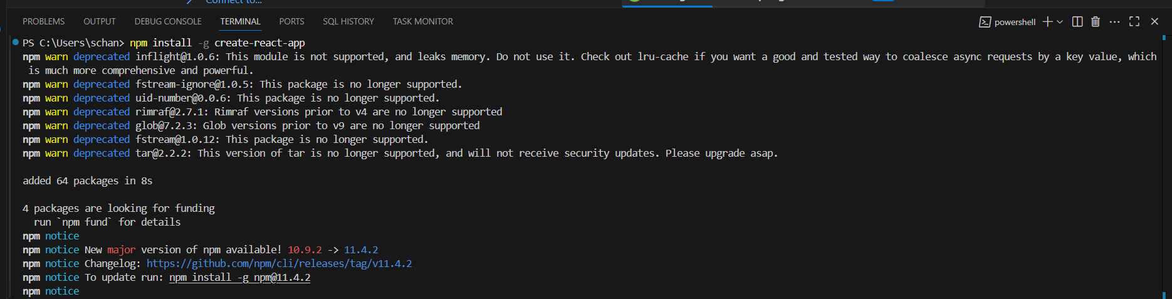
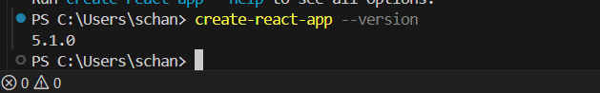
create a React Application with name “myfirstreact”.
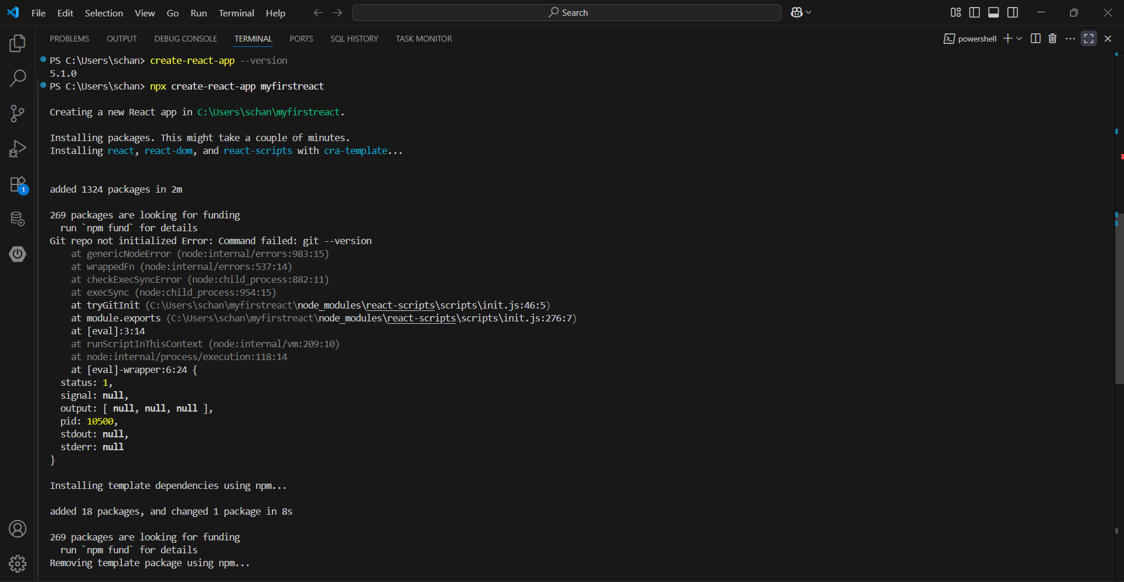
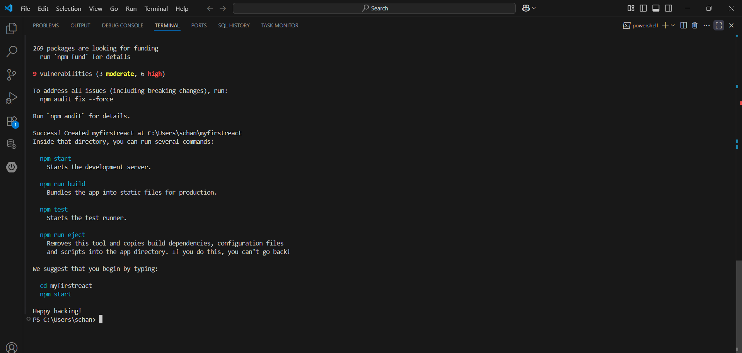
I have created the project in c:/users/schan. Moved it to the react js working directiory where i work with react in vs code.
Open the App.js file inside the src folder.
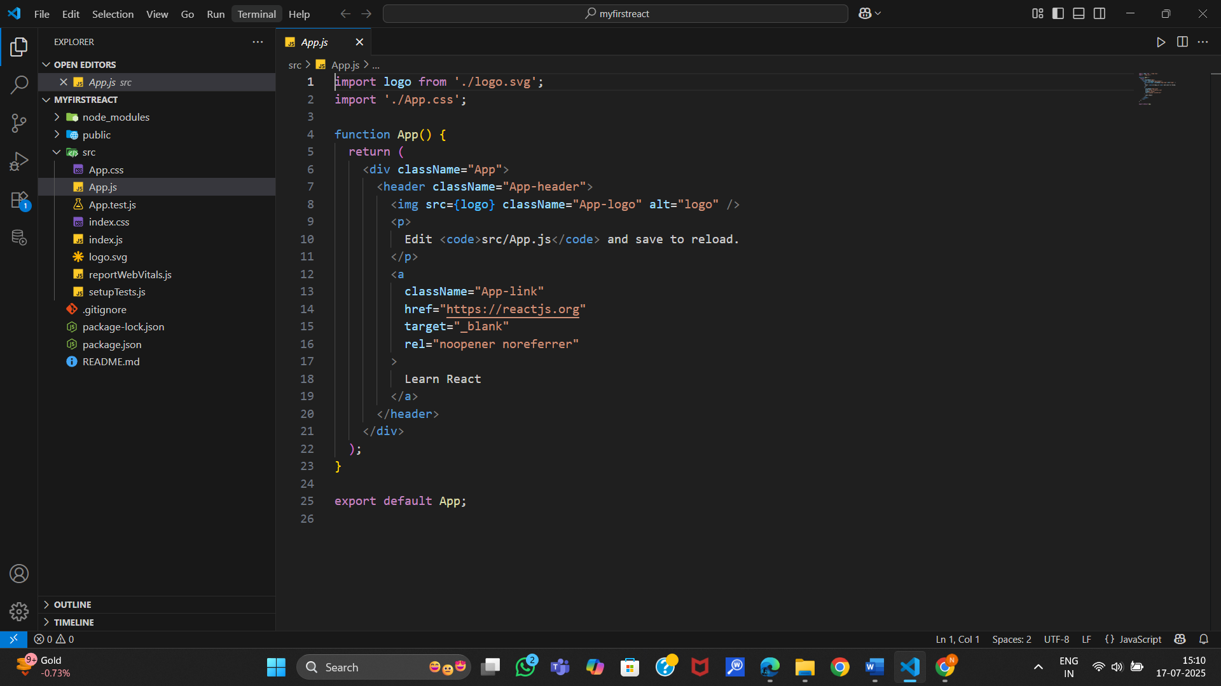
If we run the file in terminal by entering the command npm start in the terminalwe get the below one as output.
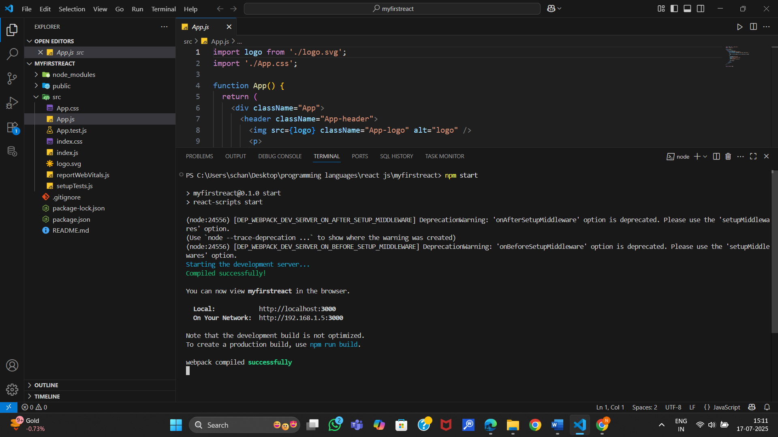
In the browser enter “localhost:3000”.
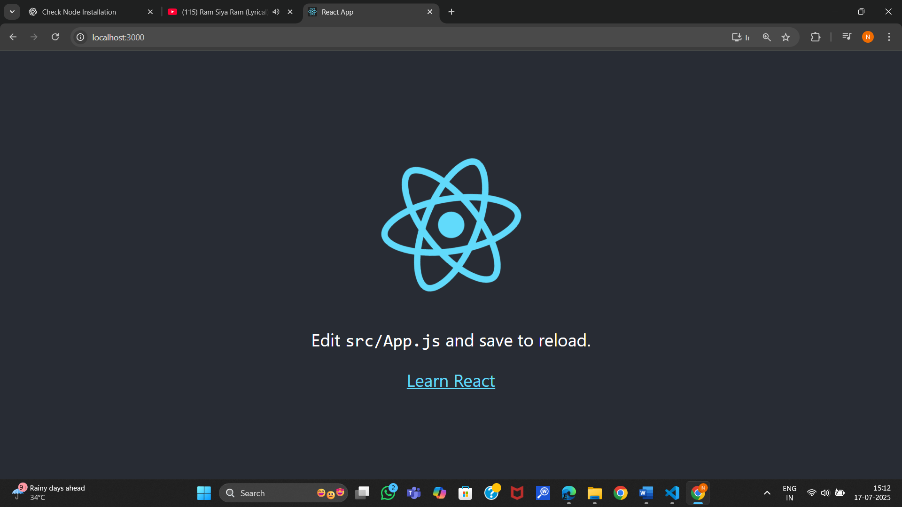
Replace the default code with below code and re-run the application.
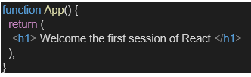
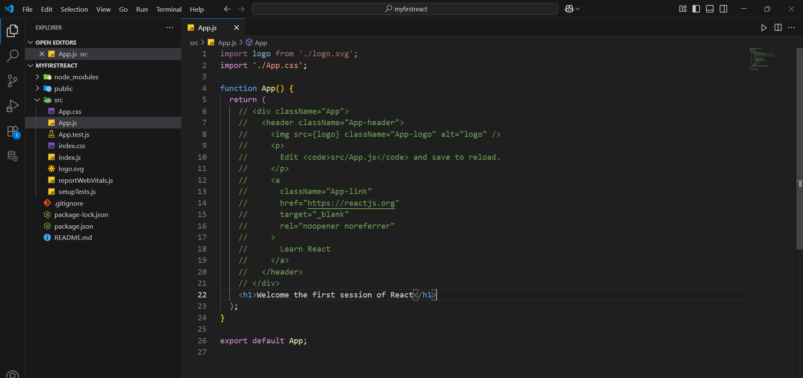
Output:
